CRUD

- Create
- Read
- Update
- Delete

- Create new table cats

CRUD -> CREATE => Create table and Insert values.

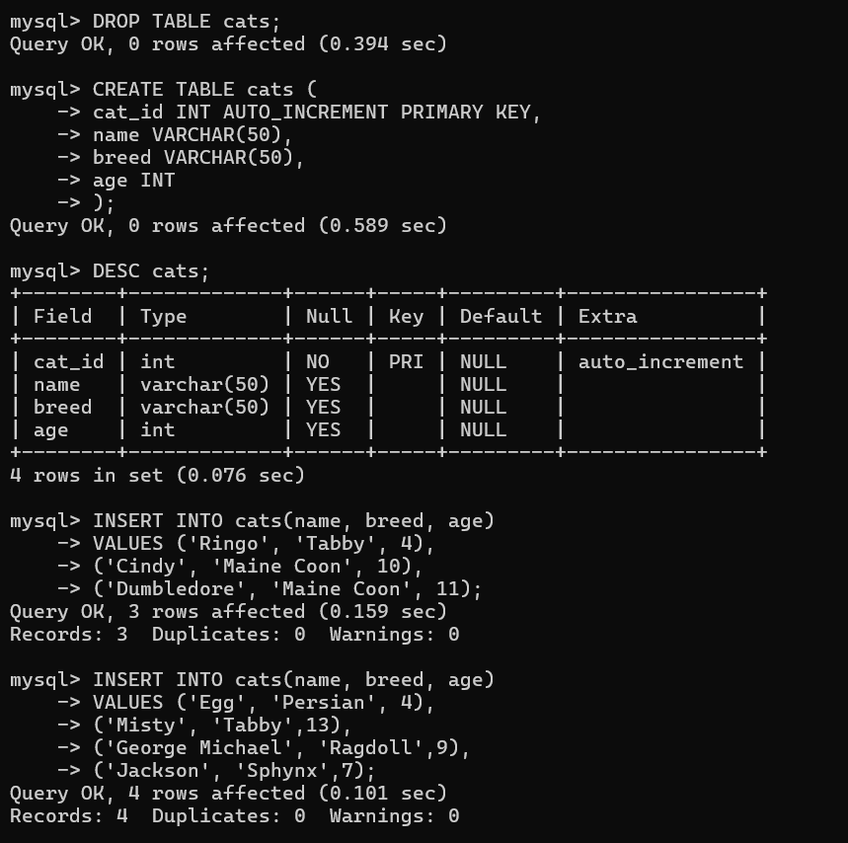

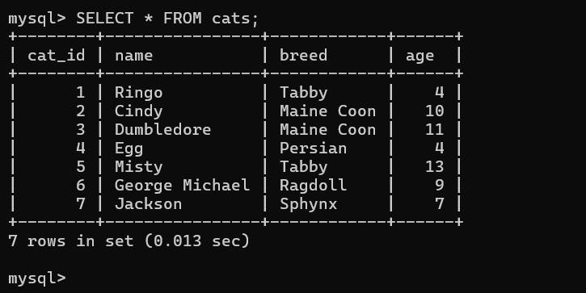

CRUD -> Read => Read data using Select Statment.

-- To get all the columns:
SELECT * FROM cats;

-- To only get the age column:
SELECT age FROM cats;
-- To select multiple specific columns:
SELECT name, breed FROM cats;

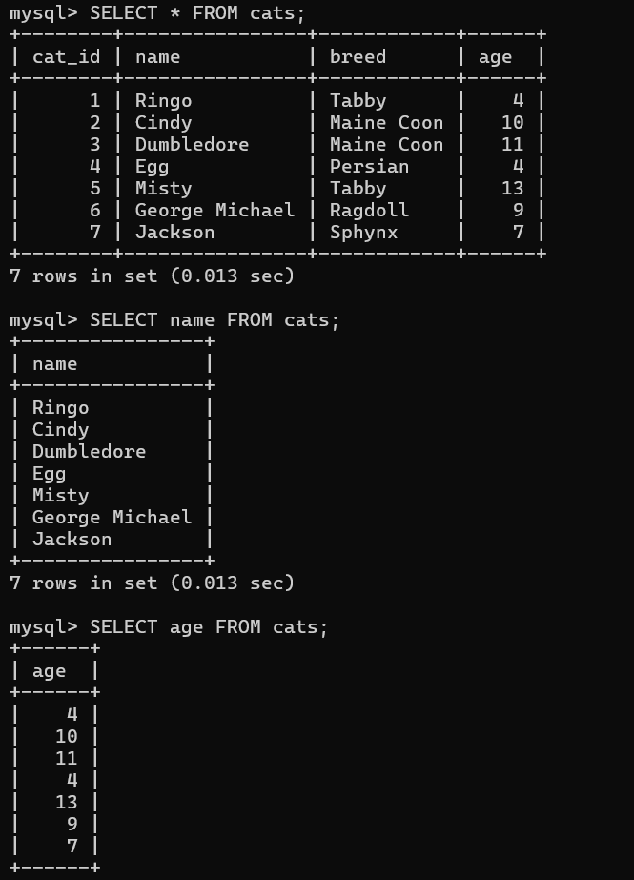
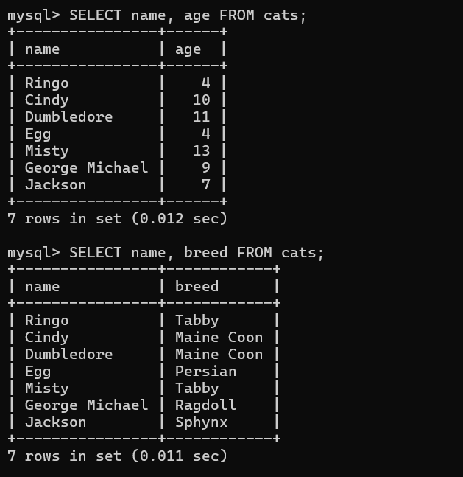

3. WHERE CLAUSE

Where Clause is used to find or update a specific column.

-- Use where to specify a condition:
SELECT * FROM cats WHERE age = 4;
SELECT * FROM cats WHERE name ='Egg';

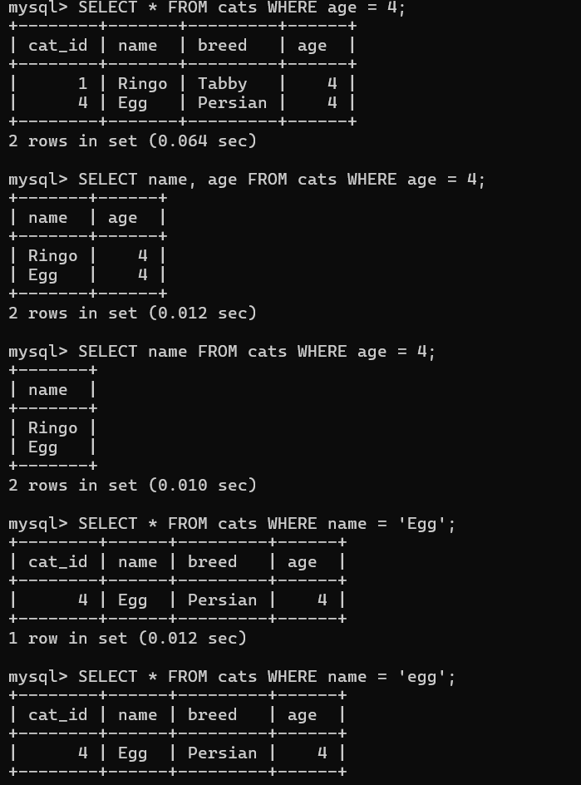

4. Aliases

Aliases command is used for temporary column name when we want to execute a command. Not permanent.

SELECT cat_id AS id, name FROM cats;

Cat_id changed as id in the cmd outcome.

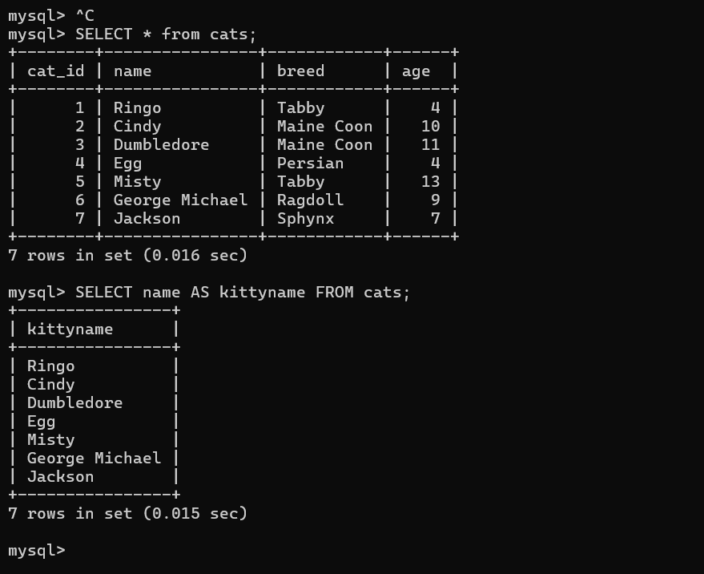

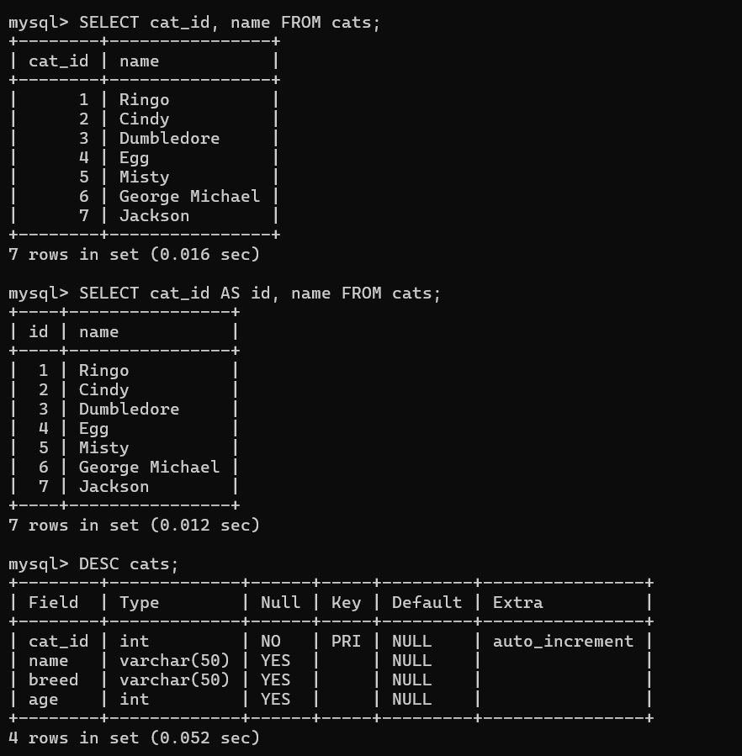

5. Update

Update command is used when a programmer updates the user id or name using WHERE CLAUSE.
Change tabby cats to shorthair:
UPDATE cats SET breed='Shorthair' WHERE breed='Tabby';
Another update:
UPDATE cats SET age=14 WHERE name='Misty';

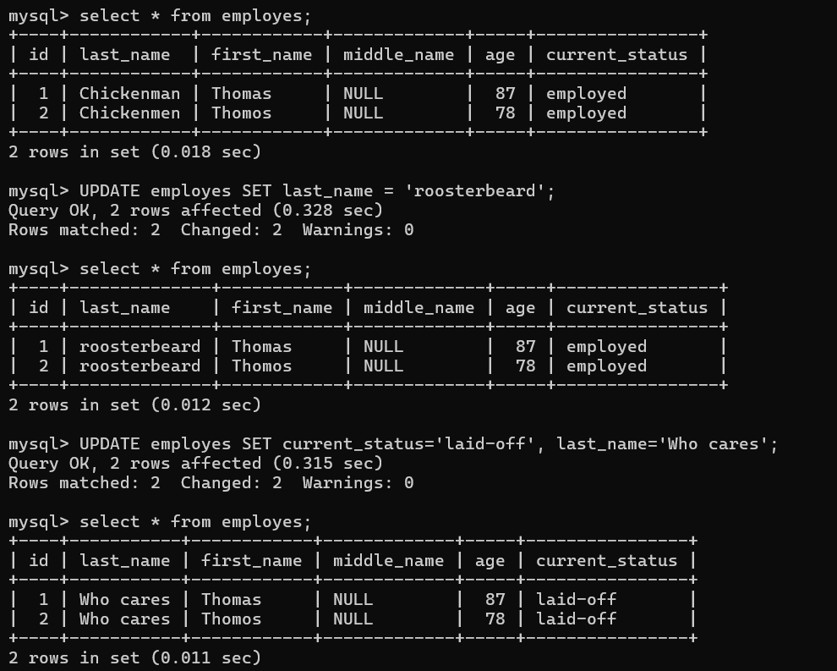

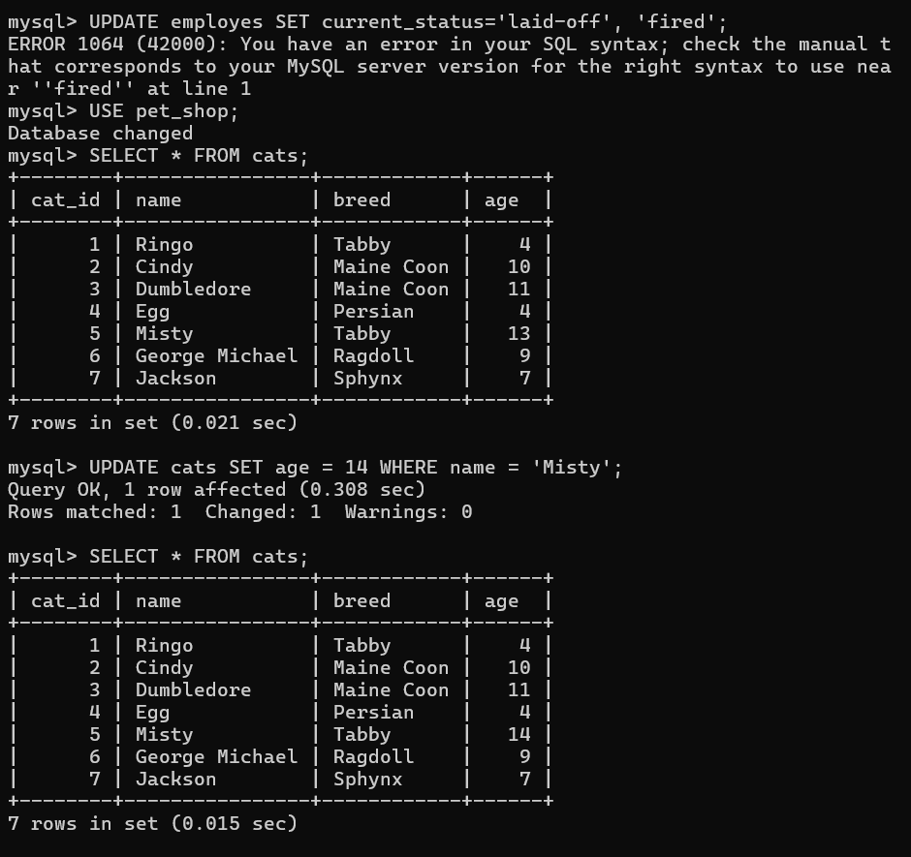

6. Delete

The delete command is used to delete a table or specific column’s data using the “where clause”.
Rows only gone otherwise columns exist using the delete from cats cmd.

-- Delete all cats with name of 'Egg':
DELETE FROM cats WHERE name='Egg';
-- Delete all rows in the cats table
DELETE FROM cats;
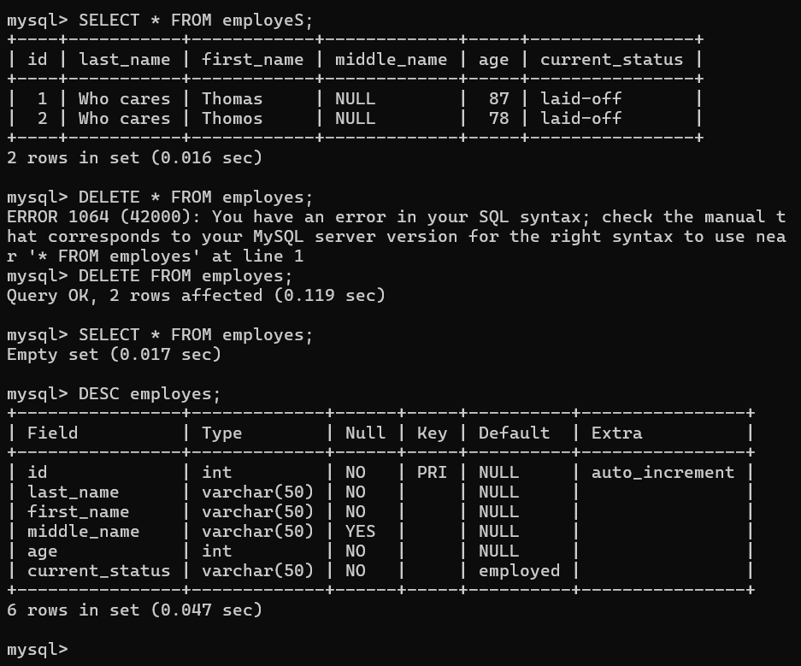
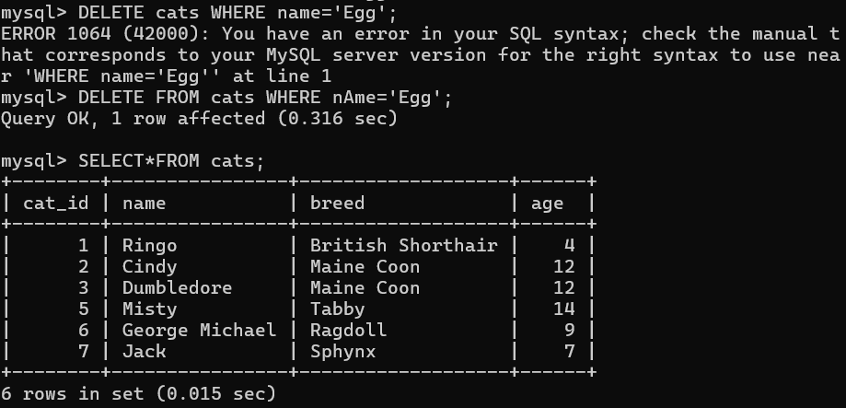

Delete Exercise

Delete a cat where age is 4.

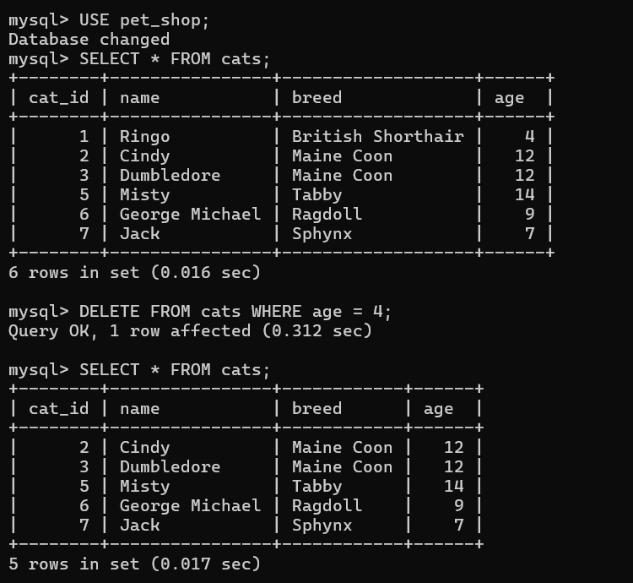

Delete cats.
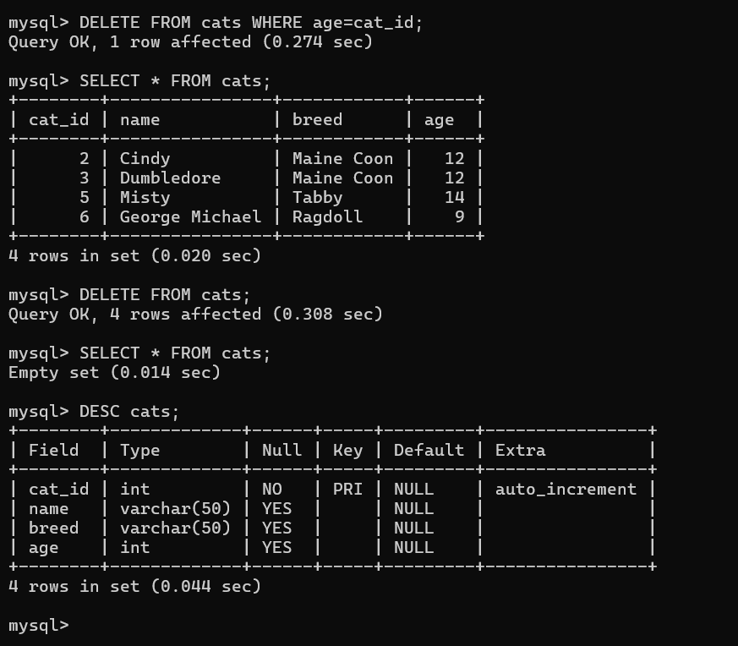

Update Exercise

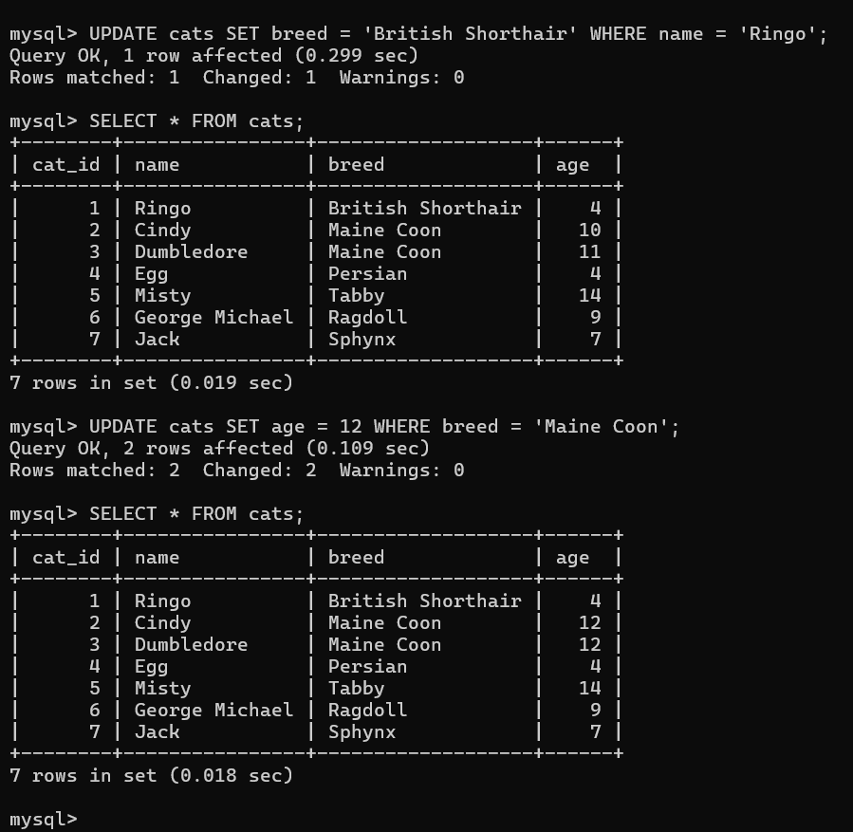

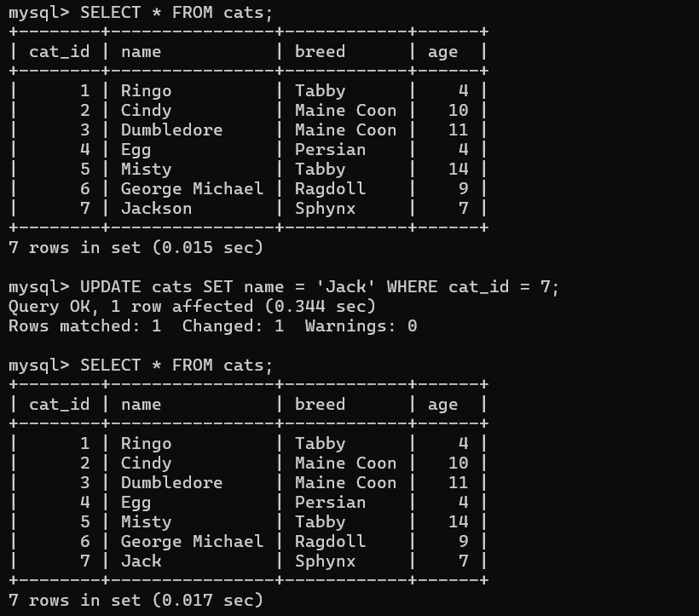

Select Exercise

